SOFTWARE TESTING – TUTORIAL 3

website:DemoBlaze: https://www.demoblaze.com/

TC01 – Verify Products Display
Test Case: Verify products are displayed
Steps:
- Open DemoBlaze.
- Observe products.
- Verify products are displayed.

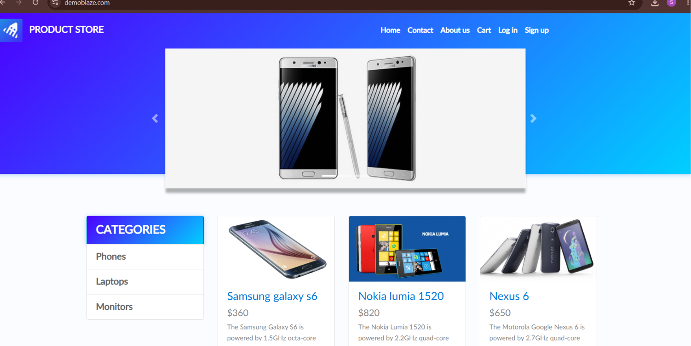
Expected Result: Products should be displayed successfully.
Actual Result: Products were displayed successfully.
Status: PASS

TC02 – Verify Product Selection
Test Case: Verify product selection functionality
Steps:
- Open DemoBlaze.
- Select a product.
- Verify product page opens.

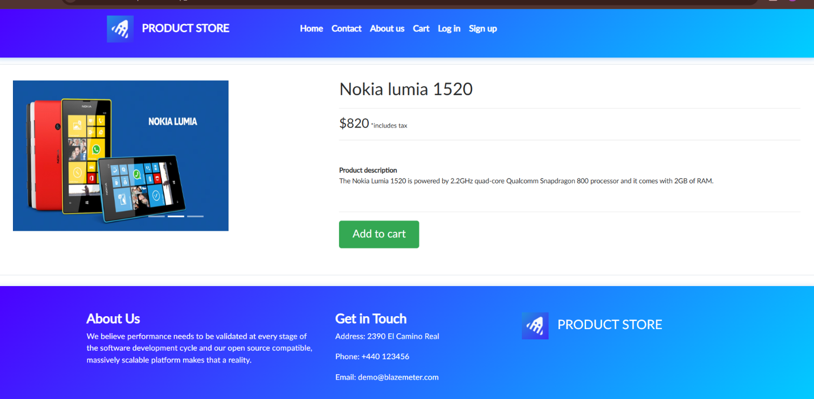
Expected Result: Product page should open successfully.
Actual Result: Product page opened successfully.
Status: PASS

TC03 – Verify Product Details
Test Case: Verify product details
Steps:
- Open DemoBlaze.
- Select a product.
- Verify product details.

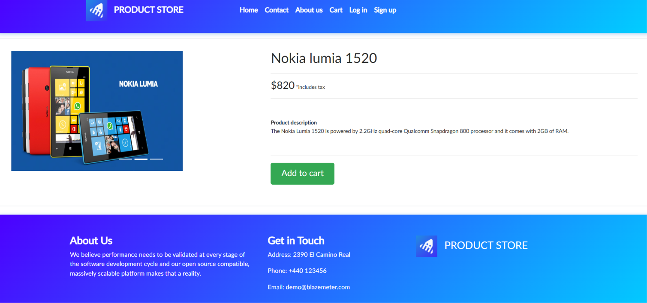
Expected Result: Product details should be displayed successfully.
Actual Result: Product details were displayed successfully.
Status: PASS

TC04 – Verify Add to Cart
Test Case: Verify add to cart functionality
Steps:
- Open DemoBlaze.
- Select a product.
- Click Add to Cart.
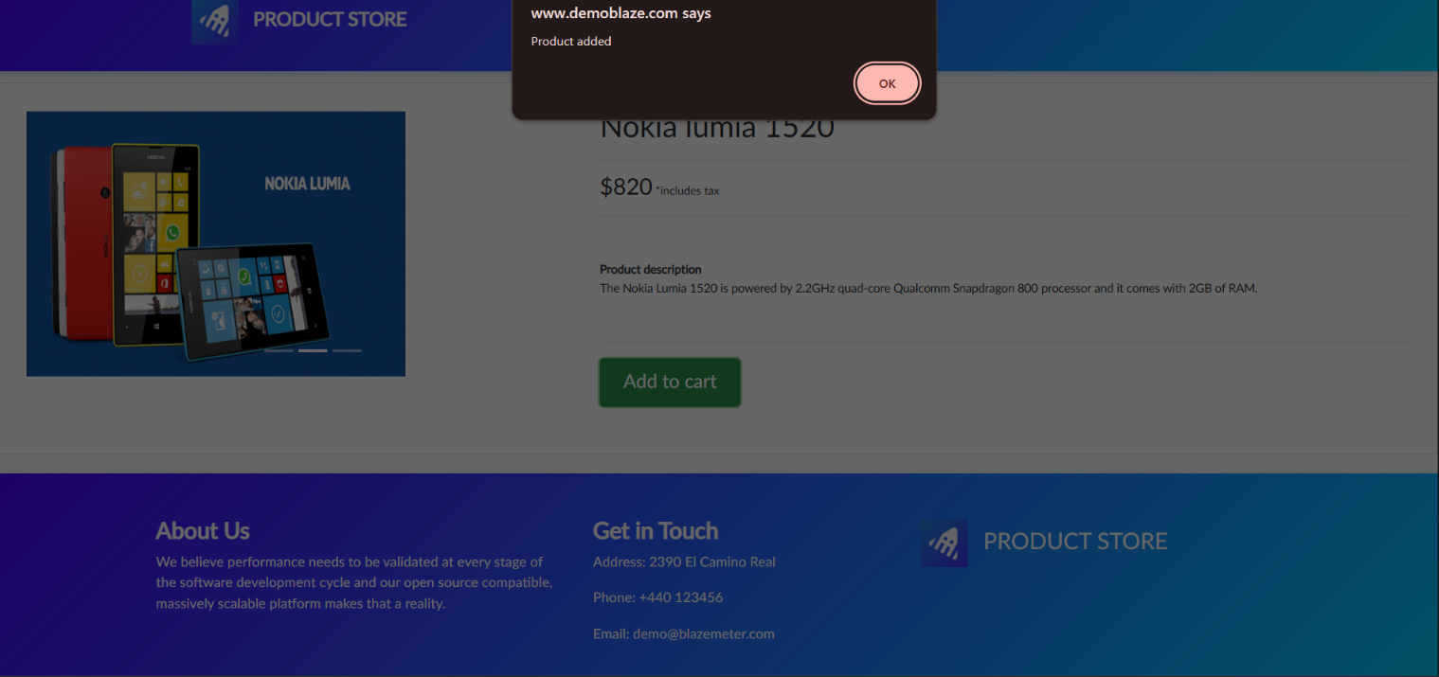
Expected Result: Product should be added to the cart successfully.
Actual Result: Product was added to the cart successfully.
Status: PASS

TC05 – Verify Shopping Cart
Test Case: Verify shopping cart functionality
Steps:
- Open DemoBlaze.
- Add a product.
- Open Cart.
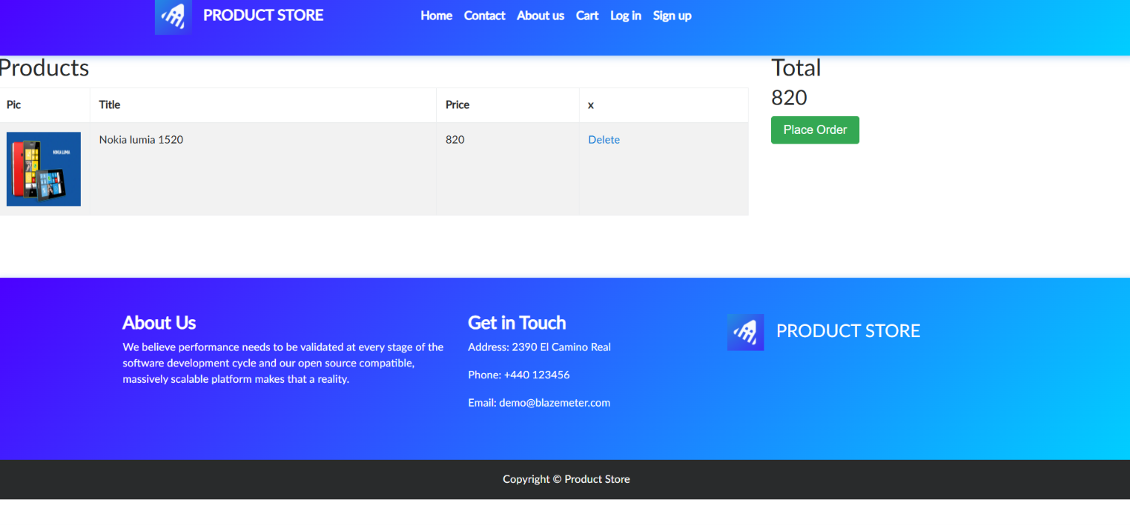
Expected Result: Shopping Cart page should open successfully.
Actual Result: Shopping Cart page opened successfully.
Status: PASS

TC06 – Verify Product in Cart
Test Case: Verify product appears in cart
Steps:
- Add a product.
- Open Cart.
- Verify the product.
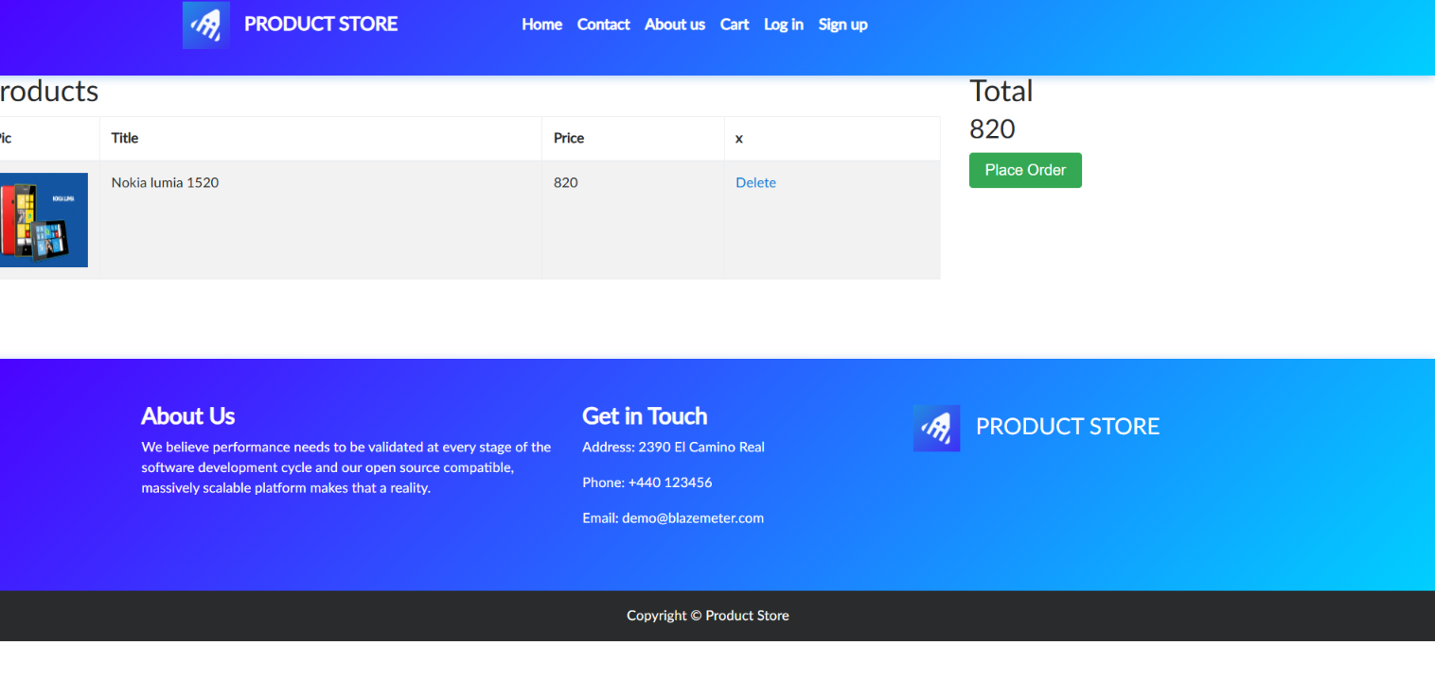
Expected Result: Added product should be displayed in the cart.
Actual Result: Added product was displayed in the cart.
Status: PASS

TC07 – Verify Remove Product
Test Case: Verify remove product functionality
Steps:
- Open Cart.
- Select a product.
- Remove the product.

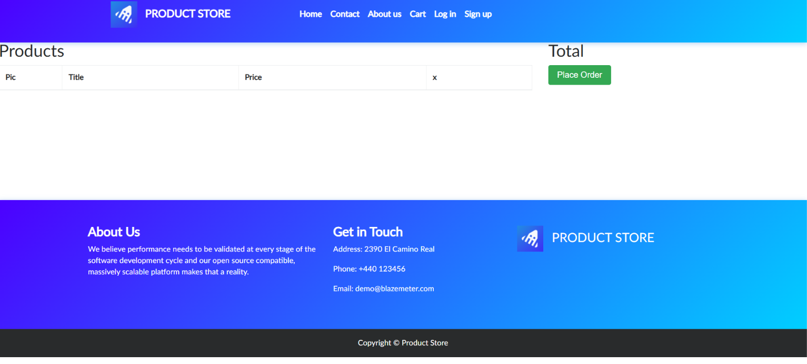
Expected Result: Function should work successfully.
Actual Result: Function worked successfully.
Status: PASS

Requirement Review

Requirement | Status | Reason
User can view products | Clear | Products were displayed
User can select a product | Clear | Product page opened
User can view product details | Clear | Product details were displayed
User can add product to cart | Clear | Product was added to cart.
User can open shopping cart | Clear | Cart opened successfully.
User can verify product in cart | Clear | Product was displayed in cart
User can remove product from car | Clear | Product was removed successfully.

Conclusion and Recommendations
Pass Rate: 100% – Application Working Successfully
Application Status: All 7 test cases passed successfully.
Issues Found: No functional issues were observed during testing.

